EIS Action Research Project

By Linsey Grant

Does the input of teacher focused sessions with pre-school children have an impact on their progression in relation to literacy, numeracy and developmental milestones?

Introduction
The ultimate goal of this research project was to discover if having regular input from a teacher impacts on their progression. It was anticipated that I would work with a group of pre-school children regularly doing focused sessions on literacy, numeracy and developmental milestones.
When schools closed in March 2020, I was responsible for planning the online learning for all the children in the nursery. I planned a weekly learning grid containing literacy, numeracy and physical activities. Unfortunately, the uptake of online learning from the ante pre-school children was very low. I am aware of the Scottish Government’s commitment to closing the attainment gap so my intentions were to try to support the children who didn’t engage in online learning and were not on track in relation to tracking for literacy, numeracy and developmental milestones.
My intentions were to spend this school session doing weekly focus teacher input sessions for groups of pre-school children who are otherwise going to be at risk of not meeting all their developmental milestones by May 2021. My methodology was as follows:
- Baseline assessment in August using literacy, numeracy and developmental milestones trackers for the groups.
- Short weekly focused teacher input sessions (literacy, numeracy and developmental milestones). I will focus on early reading and writing development, early numeracy development and use a fine/gross motor skills programme called Seaside Adventures for supporting some of the developmental milestones.)
- Termly reviews via assessment sheets.
- Observations from sessions and from key workers.
- Teacher reflection.

After deciding my research question, I spent some time planning how I was going to carry this out. Being a nursery teacher in a large nursery my plan was to work closely with the pre-school children focusing on literacy, numeracy and developmental milestones. The plan was to work once a week on each of the previous mentioned topics with the various groups of pre-school children in the nursery. This would allow me to teach a session on literacy, numeracy and developmental milestones once a week and support all the pre-school children’s progression. Part of my research project was to share documents highlighting key stages of early literacy, numeracy and motor skills with the parents and actively promote for them to be involved in their child’s learning journey.
Background
I am aware of the Scottish Government’s commitment to closing the attainment gap and wanted to try make a positive impact on this during their pre-school year, to improve their school readiness. Some of the children in my setting are from deprived backgrounds and their parents don’t have a deep understanding of child development. In 2016 The National Improvement Framework was announced by the Scottish Government. Within the National Improvement Framework there were four key priorities, two of which were relevant to my research project:
- improvement in attainment, particularly in literacy and numeracy.
- closing the attainment gap between the most and least disadvantaged children.
Within The National Improvement Framework’s key priorities there are six key drivers for improvement, again two of which were relevant to my research project:
- Parental engagement
- Assessment of children’s progress
Parental engagement
It has always been a firm belief of mine that parents (and carers) should be treated as partners in their children’s education journey. I have always actively sought to build relationships with parents and at every step of their child’s journey offered for them to be involved in their child’s learning. What I have found over the many years of working as a Nursery Teacher is that the majority of parents who are living in deprivation, don’t want to be as actively involved in their child’s education journey. As highlighted in The National Improvement Framework, “the available international research confirms that parental involvement and engagement in children’s learning supports improved attainment and achievement”. I feel this statement summarises my beliefs regarding parental involvement.
“Parental and family engagement is a key factor in helping all children achieve the highest standards whilst reducing inequality and closing the attainment gap”. This quote from The National Improvement Framework summarises one of the vital reasons I chose this research project. No child so be disadvantaged by inequality and I wanted to support as many children as possible to achieve their developmental milestones and key literacy and numeracy milestones in their development. As highlighted in the quote from The National Improvement Framework, working in partnership with parents and families is key to ensuring children get the best start in the education.

Assessment of children’s progress
Assessing children’s progress is a key aspect of a teacher’s job. As highlighted in the document Curriculum for Excellence – building the framework 5 – a framework for assessment, it states, “assessment is used to support individual learning and to provide reliable information to learners, parents…”. Alongside assessing children’s progress, reporting on progress and achievement is equally important. Reporting progress and achievement (both formally and informally) to the parents/carers is an opportunity to discuss children’s strengths, development needs, and their progress being made. As outlined in the Curriculum for Excellence – building the framework 5 – a framework for assessment, it highlights that there is an expectation for most learners to achieve Early Level by the end of Primary 1. As the children can spend approximately 2 years of their time at Early level in Nursery, I felt it was key to actively assess the children’s progress against literacy and numeracy and against Perth and Kinross’ developmental milestones and share any progress and achievements with both the child’s keyworker and parents.
Research Design
My research project plan was to consist of:
- Completing a baseline assessment of the pre0school children in August in relation to literacy, numeracy and HWB (incorporating PKC Developmental Milestones).
- Short weekly sessions with the pre-school children focus on early reading and writing development, early numeracy development and use a fine/gross motor skills programme called Seaside Adventures for supporting some of the developmental milestones.)
- Work with a group a day, giving me the opportunity to mix with each of the 5 groups
- Termly meetings with the keyworkers to discuss planning, children’s progress and any additional support that could be required.
- Monitoring of observations of children and of observations on Seesaw.
- End of year assessments, tracking and monitoring.

In August 2020, upon return with COVID-19 restrictions in place in school I very quickly reduced my research project from working with all the pre-school children to working with a group of preschoolers in one nursery group, The reasoning behind this reduction of my planned interactions was due to personal family circumstances and the risk of taking home COVID-19 if I was to be interacting with 70+ families.
I started my project by completing baseline assessments on of the pre-school children in a group. The criteria I used for the assessments included aspects of early reading, early writing and early numeracy. From the results of the baseline assessments, it was decided that I would work with a group of pre-school children who were developmentally not where they should be. This consisted of 7 pre-school children (5 girls and 2 boys) and in December reduced to 6 pre-school children (4 girls and 2 boys). My teacher led sessions varied from weekly to fortnightly due to children’s attendance patterns and ensuring the children’s free play wasn’t too broken by interruptions. From August to December there was a mixture of observations, teacher input and meetings between me, the nursery teacher, and the children’s keyworkers. From these meetings we were able to acknowledge children’s progress and gauge what support was needed through completing termly tracking sheets in relation to literacy, numeracy and HWB, as well as completing developmental milestone trackers.
In December 2020 it was announced that schools were to be closed and resulted in remote learning taking place from Monday 11th January to Friday 19th February. During this time, I reverted to online planning and was slightly concerned how this would impact on my research project. However, after a period of reflection, I realised that remote learning could incorporate activities which would focus on key aspects of literacy, numeracy and HWB to allow me to continue to support the pre-school children. I recorded 2 weekly videos modelling the activities and actively promoted children to participate in the activities and share their videos on Seesaw of them completing the activity. From 11th January to 19th February the levels of engagement to remote learning averaged at about 65-70% weekly, a massive increase on the previous lockdown.
Upon return from the second period of school closure, there were still strict restrictions in place in relation to COVID-19 resulting in the lack of opportunities to interact with the parents on a regular basis. Interactions are key to building up a rapport with the parents in the nursery and with the social distancing and Covid-19 restrictions in place, this has hindered this slightly. In addition to the qualitative data gathered prior to remote learning, I decided to gather quantitative data through a parent survey, asking them if they wanted video input to continue. I asked the following questions:
- On a scale of 1-10, how well do you feel you understand and can support your child's educational development?
- Do you feel recorded sessions from the nursery teacher around the topics of literacy, numeracy and developmental milestones would be of benefit to you?

The results of these questions were as follows:
- 8.3 out of 10 for level of understanding and providing support
- 18 responded yes, 1 responded no and 1 maybe.

As a result of this survey I began to record videos explaining key developmental stages of early literacy and early numeracy, including shoulder, elbow and wrist pivot, pre-counting, early counting and numbers in the environment. In March 2021 I moved into teaching Primary 1. From March 2021 to June 2021 these videos were shared weekly on Seesaw for the parents to watch and for the keyworkers to access. In June 2021 I surveyed the parents again for feedback. The following questions were asked:
- How well do you feel your understanding about your child's early literacy and numeracy journey has developed? – answers options were it has stayed the same/I have a better understanding/I have a much better understanding.
- Do you feel the recorded sessions and handouts from the nursery teacher around the topics of literacy, numeracy and developmental milestones were of benefit to you? – answer options were yes/no.
- Which area(s) do you feel were of benefit to you? – answer options were Early Literacy/Early Numeracy/Fine Motor Skills.

The results of these questions were as follows:
- It has stayed the same (0), I have a better understanding (7) and I have a much better understanding (5).
- Yes (12), No (0)
- Early Literacy (9), Early Numeracy (10) and Fine Motor Skills (10)

Findings and analysis
I started my research by carrying out a baseline assessment on literacy, numeracy and health and wellbeing as below.
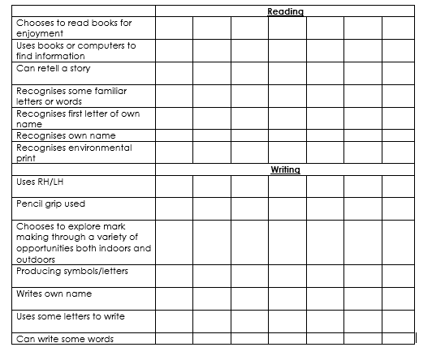

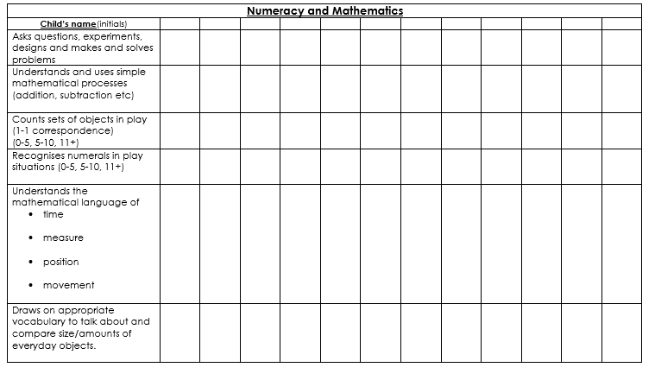

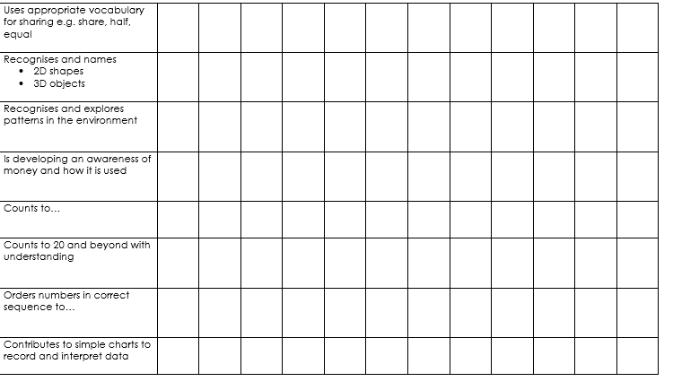

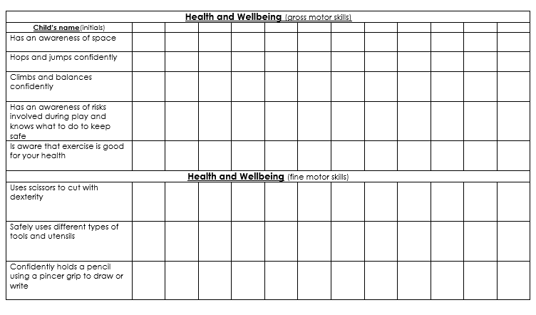

From the results of the baseline assessments, it was decided that I would work with a group of pre-school children who were developmentally not where they should be. This consisted of 7 pre-school children (5 girls and 2 boys) and in December this number reduced to 6 pre-school children (4 girls and 2 boys) as one child moved away.
Through termly meetings and discussions with the keyworkers, in September and December, I found that staff felt confident in supporting children’s developments and are skilled at identifying the next steps for the children. Through weekly sessions with a teacher and observations, it was evident the children were starting to make progress in early literacy and numeracy. In early literacy they were able to either recognise the initial letter of their name, their name without a picture symbol or begin to write their name. In early numeracy their 1-1 correspondence was developing, their number recognition was widening, and they were beginning to form numbers.
In January 2021 schools were closed for a second time and we reverted to online learning. At this point my research project took a different path as I needed to try engage with the preschool children whilst they were at home. My research project changed to recording two videos weekly, one literacy related, and one numeracy related, and I shared these online using the platform Seesaw. I set children a challenge in relation to each video, and all activities were planned to incorporate early literacy and early numeracy progression.
Overall, during the period from 11th January to 19th February, 33 out of 43 pre-school children engaged with online learning most weeks and shared their home learning with us via Seesaw. This was significantly higher than the first period of remote learning.
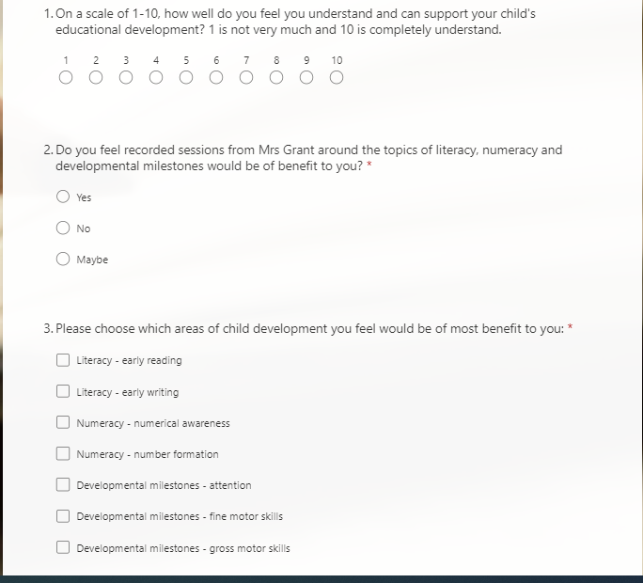
Upon return to nursery in February, I shared a survey with the parents to gather their thoughts on continuing sharing videos/handouts with them to support their children’s progression in relation to literacy, numeracy and fine/gross motor skills. Out of 43 families, 20 answered and I got the following quantitative data:

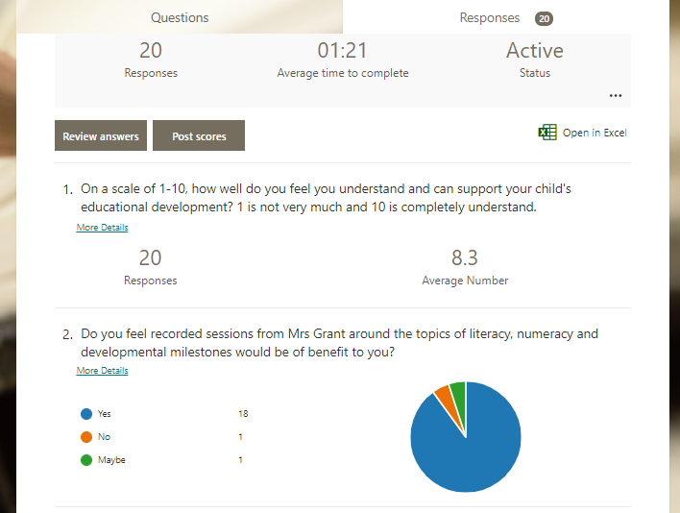

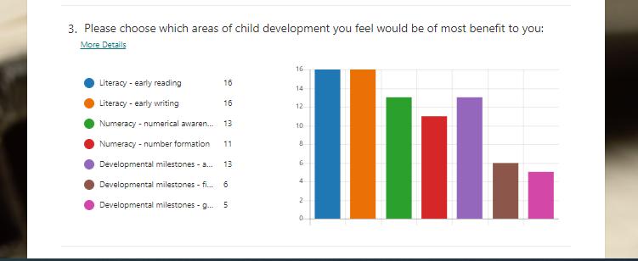

The survey showed that parents felt that videos/handouts would be of benefit, and in particular early reading, early writing, numerical awareness and attention. As the home environment and interactions from parents/carers are key to a child’s development I felt that I needed to deepen their understanding of how to support their child’s progression in relation to literacy, numeracy and developmental milestones. In March 2021 I transitioned from being the nursery teacher to being a primary 1 teacher so recorded videos and shared handouts was the best way to engage with both parents and keyworkers and continue to support the children’s progression. The keyworkers had access to planned group time planners, outlining key literacy, numeracy and HWB experiences and outcomes, modelled activities relating to the story of the fortnight and they had access to the videos and handouts shared by the teacher. All these opportunities ensured that the children were still being supported through teacher-led opportunities and parents’ understanding was being developed as they were receiving weekly videos/handouts from myself in relation to either literacy, numeracy or developmental milestones.
After all the videos and handouts were shared with the parents, I shared another survey with the parents to gather further quantitative data on their thoughts. The data gathered is as follows:

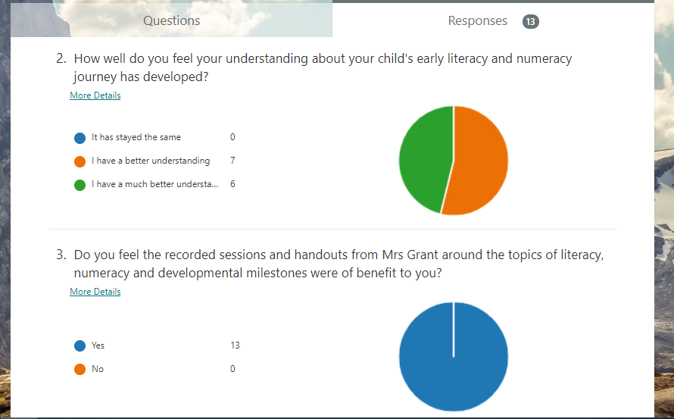

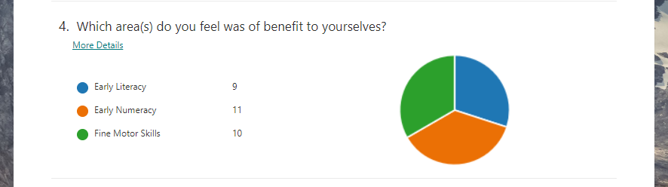

In June 2021, a teacher worked with all the pre-school children carrying out literacy assessments using the criteria below:
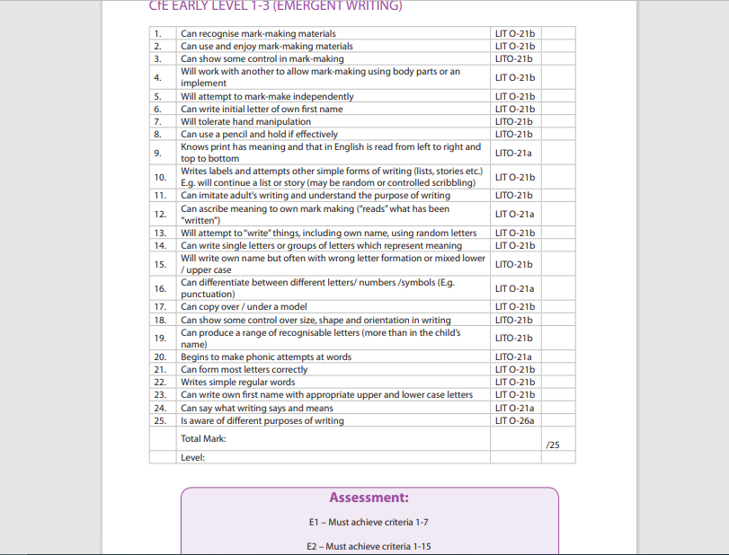

These assessments highlighted significant progress in relation to early literacy. Almost all the pre-school children coming into Primary 1 have achieved at least criteria 1-7 upon entry to Primary 1.

Conclusions
Despite my results showing progression in relation to literacy, numeracy and developmental milestones, it is difficult to identify to what extent the teacher input and teacher led sessions/videos/handouts have contributed to this. It is impossible to isolate different external factors such as parental interactions, quality learning experiences and children’s natural desire to learn. However, there are several key benefits to children receiving teacher’s input in relation to literacy, numeracy and developmental milestones.
Moving forwards in terms of my own practice, I intend to develop further opportunities to engage with parents and share key aspects of children’s progression in relation to literacy, numeracy and developmental milestones and to engage with staff to provide more frequent, high quality staff development opportunities to support their own understanding. It is vital to provide regular opportunities for staff to engage in professional discussions with the teacher, to discuss children’s progression and identify next steps in their learning. Early identification of children who are developmentally behind allows for early intervention and planned support to be provided in order to enable them to meet the key milestones in the learning.
References
Bryce-Clegg, A. (2013) Getting ready to write, Featherstone: London.
Keith, L. (2017) Developing Young Children’s Mathematical Learning Outdoors: Linking Pedagogy and Practice, Routledge: Oxfordshire.
Cowley, S. (2019) The Ultimate Guide to mark Making in the Early Years, Featherstone: London.
Beeley, K. (2019) Maths makes the world go round, Playing to Learn - Kirstine Beeley www.playingtolearnuk.com
Scottish Government (2019) 2020 National Improvement Framework and Improvement Plan. Edinburgh: Scottish Government.
Scottish Government (2016) Making Maths Count. Edinburgh: Scottish Government.
Fisher, J. (2016). Interacting or Interfering? Improving interactions in the early years, Open University Press, UK ed.
Read on. Get on (2015). Ready to Read: Closing the gap in early language skills so that every child in Scotland can read well. London: The Save the Children Fund
Wright, R.J, Martland, J & Stafford, A.K. (2008) Early Numeracy Assessment for teaching and intervention, SAGE publications: London.

